Lewis Magdamo, Cecilia Munasque & Hillary Sanchez

Part 2: Designing Alternatives

**Scenario:**

1. The Dela Cruz family is on vacation, they are eager to explore the local attractions. They based their itinerary on the reviews and ratings of the place but also having to plan their route.
2. Maria, a college student, has just moved to a new city, being unfamiliar with the area, she aims to find places that suit her study needs and personal preferences.
3. Tasked to find a venue for her friend’s birthday party, she searches for top-rated restaurants.

**Storyboard (Based on Scenarios):**

**Problem Statement:**

* People experiencing difficulties when navigating in urban areas
* People having problems with identifying good places to hang out

**Application Icon Size Comparison:**

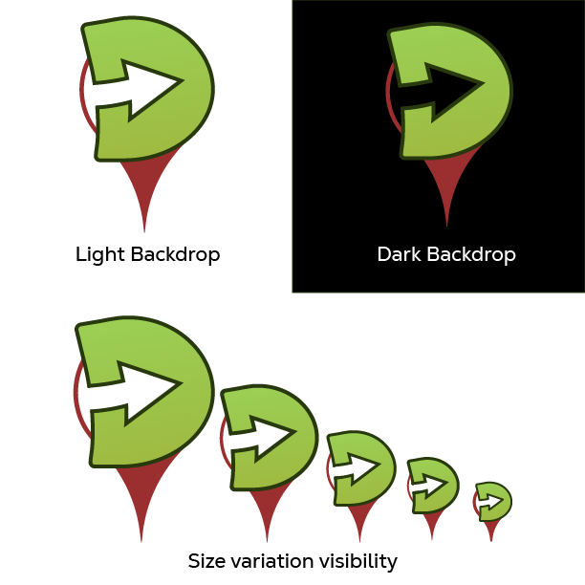

**Design**

The DavGo application aims to showcase a modern-minimalistic design. There are similar designs from the application Google Maps, considering how that application is our basis, the same as Grab. To achieve this design, the following will be identified: Color Palette and GUI.

**Color Palettes**

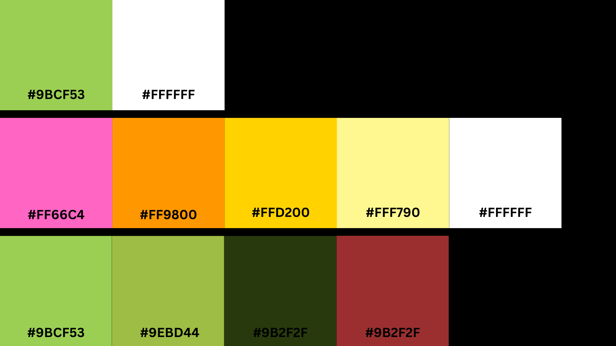

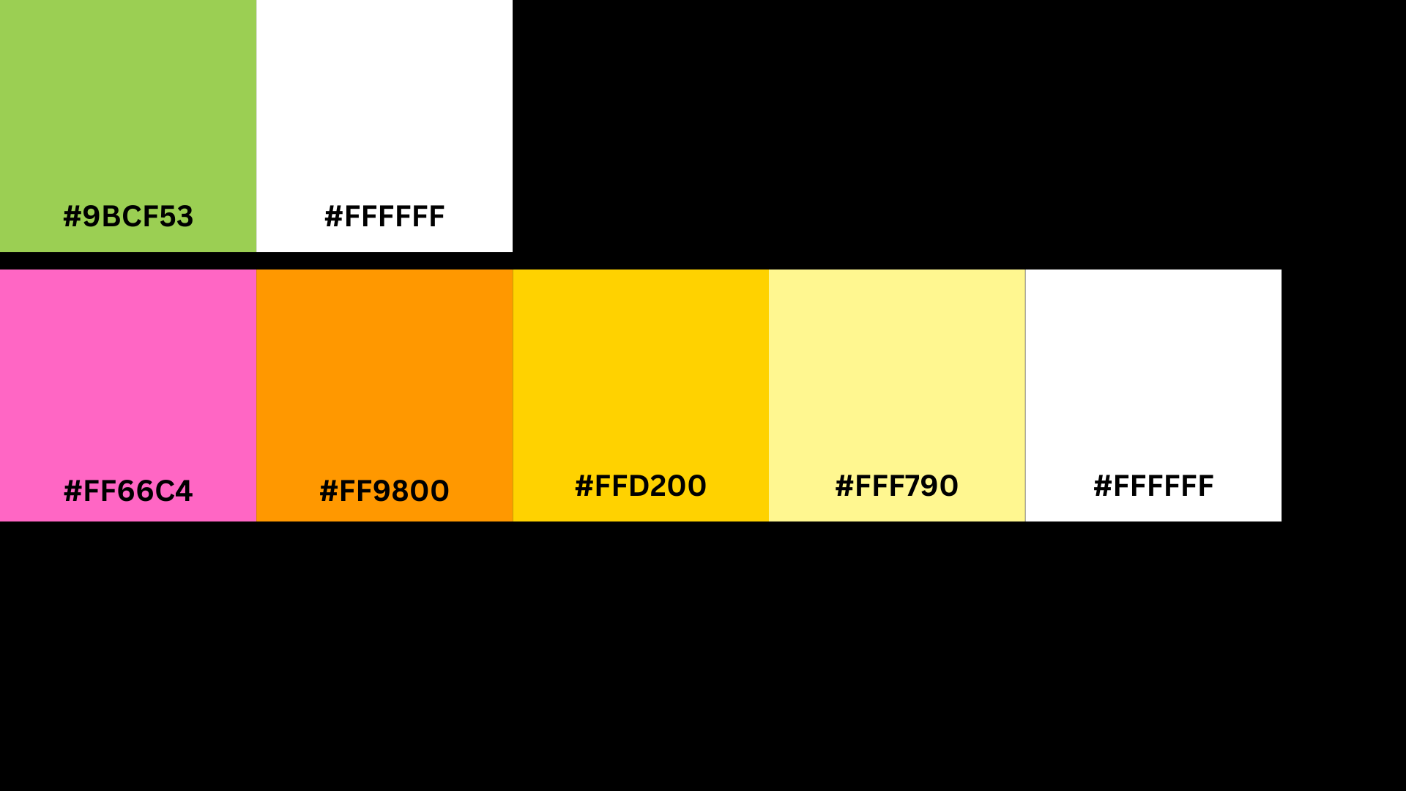



The different color palettes shown above with their codes have been selected to be used in the application.

**GUI**

The team made use of the iPhone GUI for the application since the iPhone GUI is known for its consistent and familiar layout. The team will be adopting the iPhone GUI from Miro for this application.

**Sample Feature Flows**

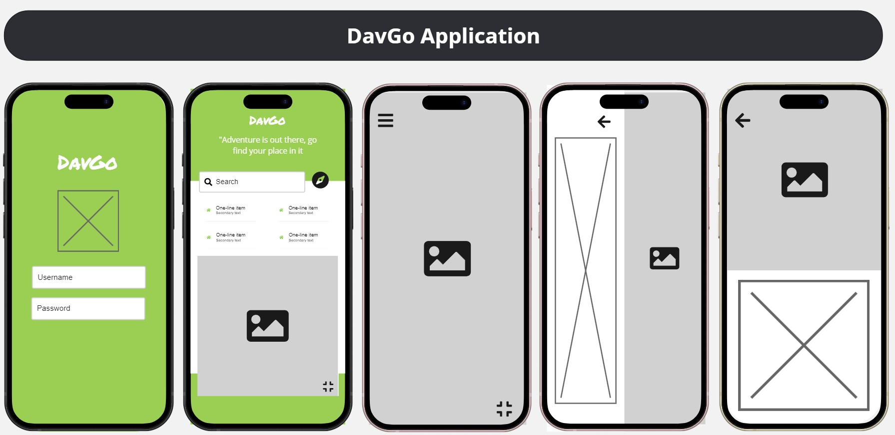

This is the sample flow of the different features that can be seen through

|  |  |
| --- | --- |
|  | 1. **This is where the DavGo logo will be displayed** 2. **The user needs to input their username and password to enter the app** 3. **This is where users search for their desired location** 4. **Events or sales of places** 5. **Minimized version of the map**   The CRUD (Create, Read, Update, Delete) feature applies here by letting the user create account and add places, reviews, and/or events, businesses can even create posts to promote their business or events, users would be able to view, update, or delete their own reviews. |
|  | **Full display of the map**  This would appear if the user pressed the full screen button on the minimized map. |
|  | 1. Where details of the place would be displayed, alongside a search bar so the users would be able to still search for a new place. 2. Displays information about the place with a picture above. |

**Design Sketches and Alternatives**

The team has created a series of designs to be used in the application, with the plan to integrate D and G with the navigation pin.

